**OPERATING**

**SYSTEM**

**LAB – 3**

**Vi Editor and Filter Commands.**

**Submitted by: ~**

**Ayushi Kumari**

**RA1911003010865.**

Q1. Write a command to cut 5 to 8 characters of the file f1.

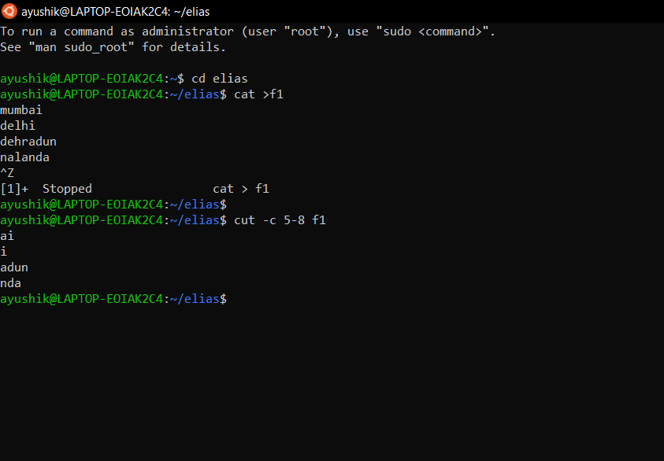

Q2. Write a command to display user-id of all the users in your system.

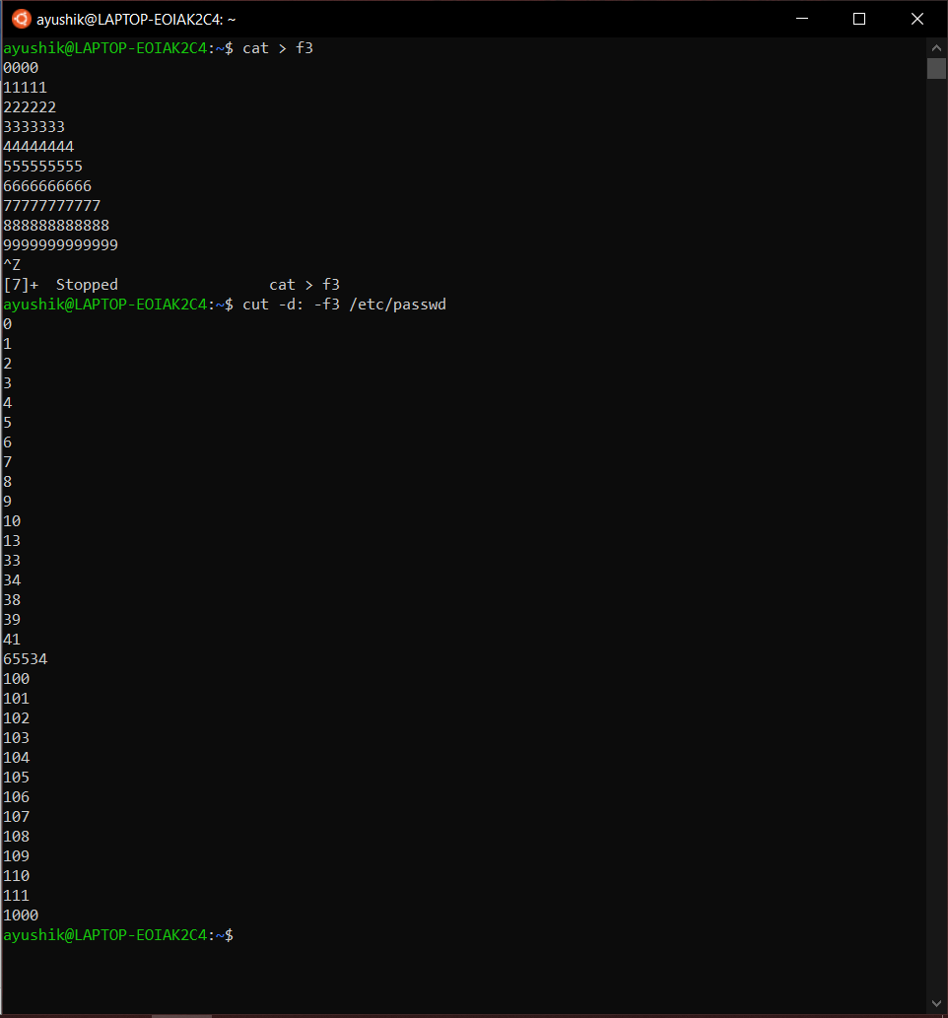

Q3. Write a command to paste all the lines of the file f1 into single line  
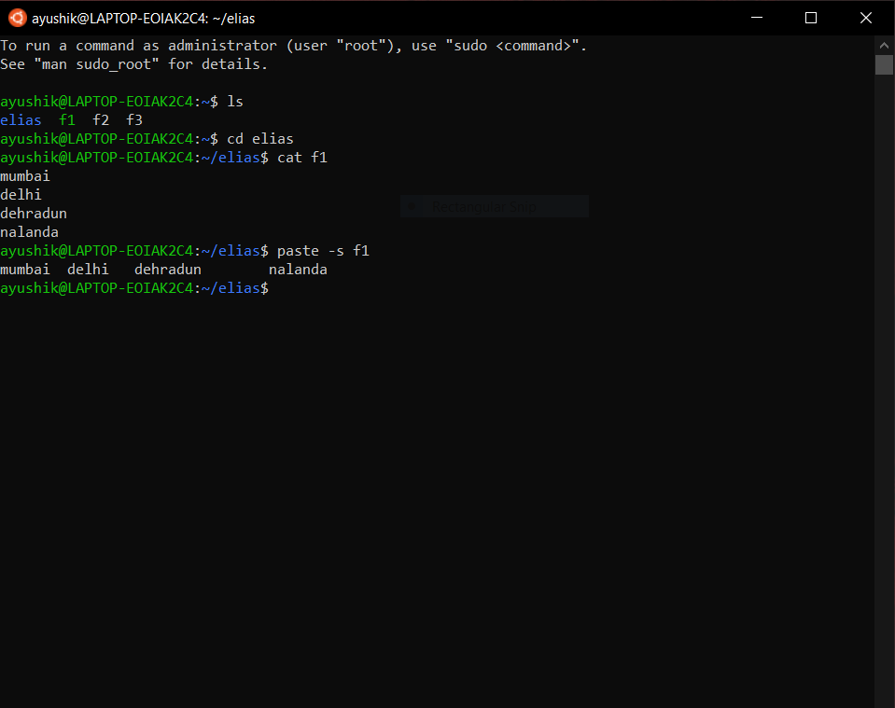

Q4. Write a command to cut the first field of file f1 and second field of file f2 and paste into  
the file f3.

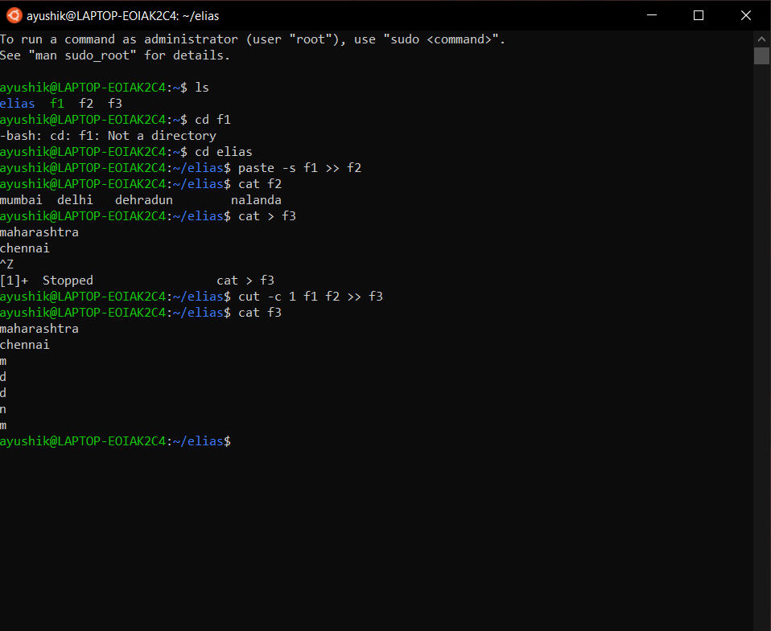

Q5. Write a command to change all small case letters to capitals of file f2.

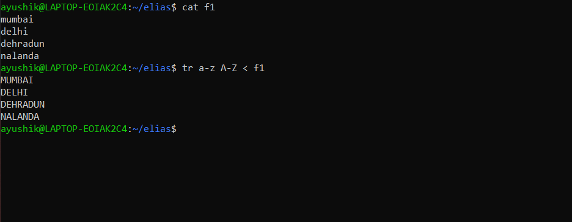

Q6. Write a command to replace all tab character in the file f2 by :  
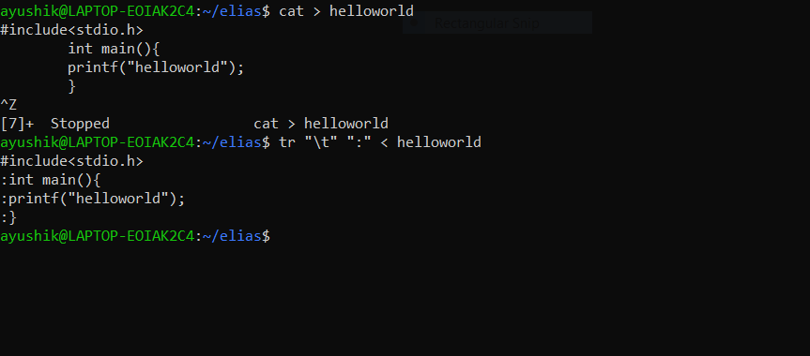

Q7. Write a command to check whether the user hitik is available in your system or not.  
(use grep)

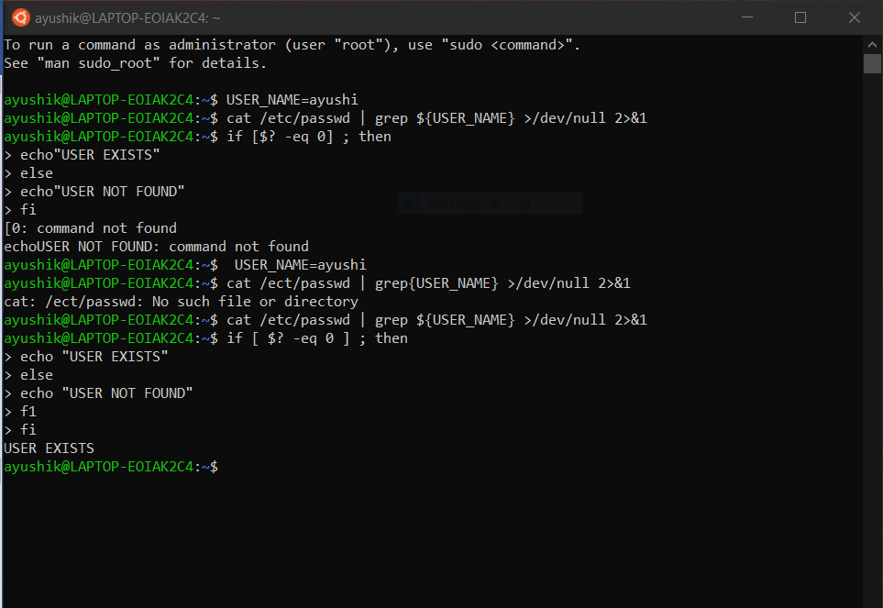

Q8. Write a command to display the lines of the file f1 starts with SRM.

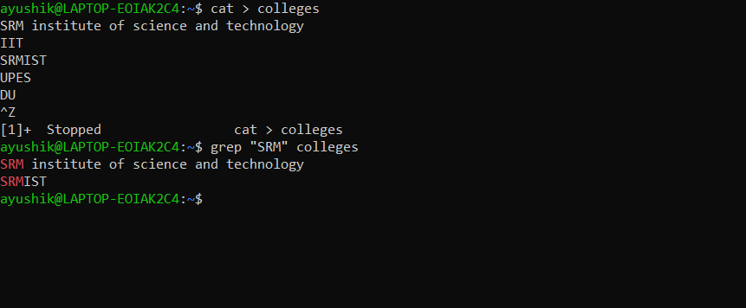

Q9. Write a command to display the name of the files in the directory /etc/init.d that  
contains the pattern grep.

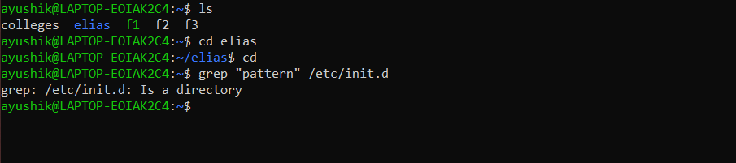

Q10. Write a command to display the names of nologin users. (Hint: the command nologin  
is specified in the last filed of the file /etc/passwd for nologin users)

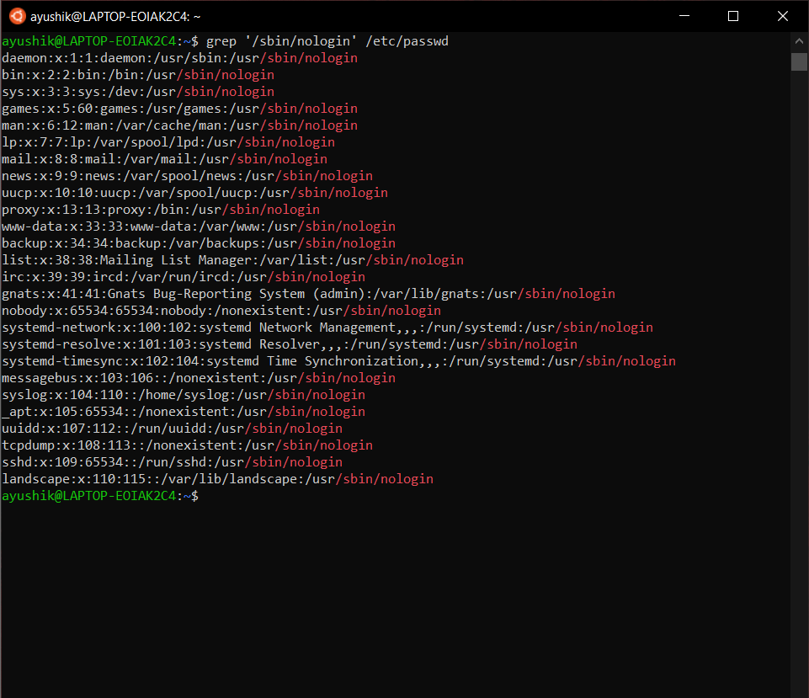

Q11. Write a command to sort the file /etc/passwd in descending order

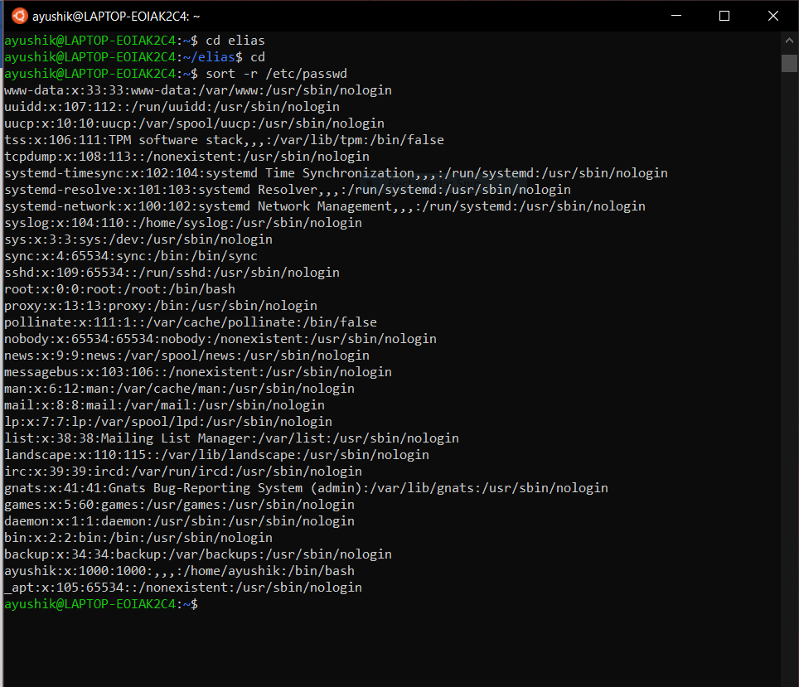

Q12. Write a command to sort the file /etc/passwd by user-id numerically. (Hint: user-id is  
in 3rd field)

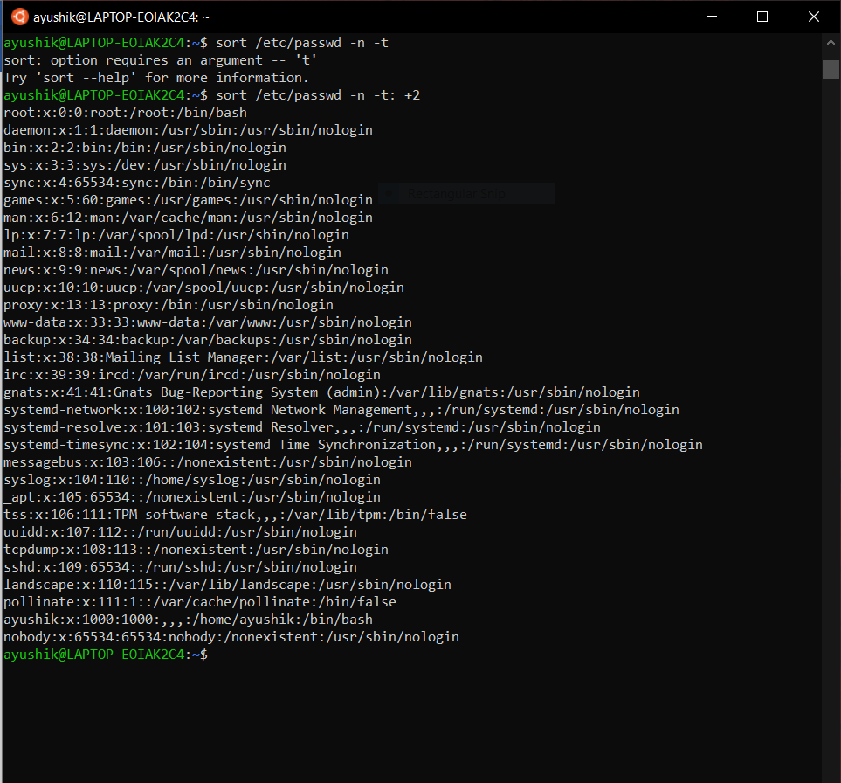

Q13. Write a command to sort the file f2 and write the output into the file f22. Also  
eliminate duplicate lines.

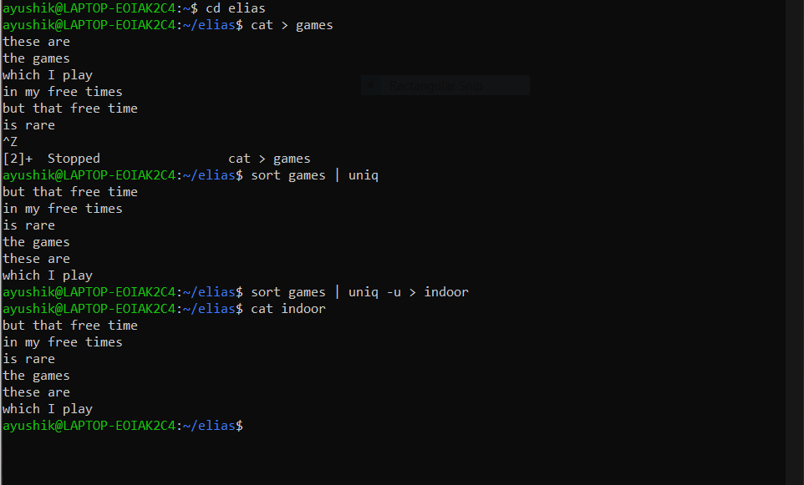

Q14. Write a command to display the unique lines of the sorted file f21. Also display the  
number of occurrences of each line.

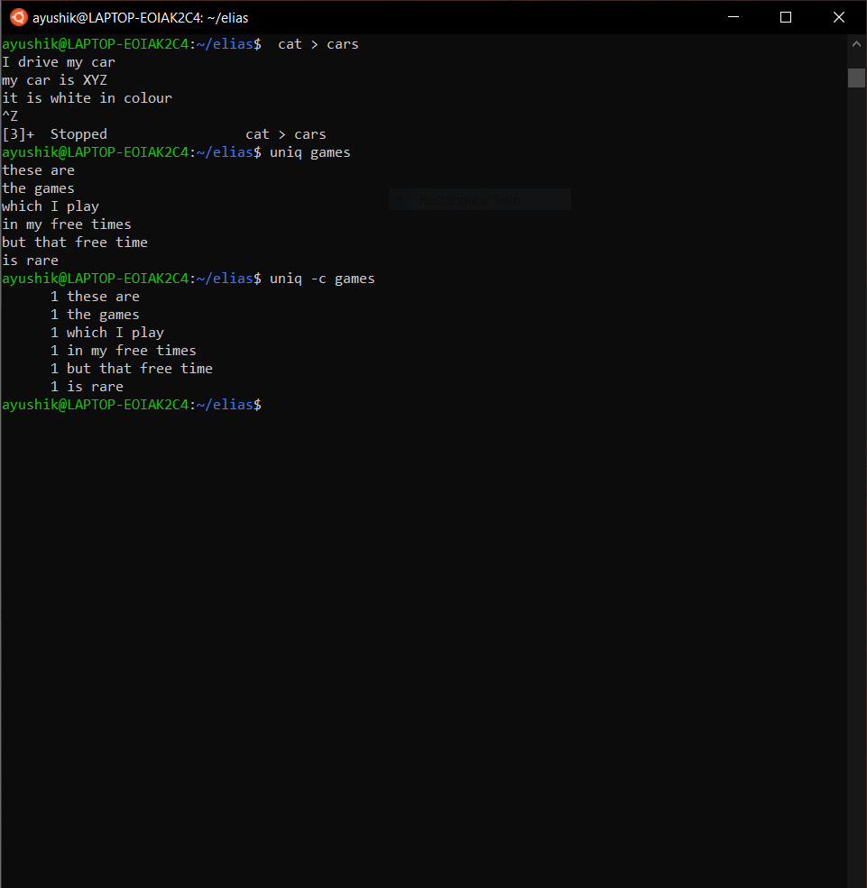

Q15. Write a command to display the lines that are common to the files f1 and f2.

